User Requirements research notes

# Product

# Research techniques used

**Technique: Ethnographic interview**

UX booth collaboration (2018, October 17th)

**Method and Justification:** Create and carry out an interview with a series of leading questions designed to understand the role of a Lecturer in respect to taking class attendance, and how they use the recorded data. These questions will include how they go about carrying these tasks within the current system. The goal is to establish a list of possible system requirements and limitations.

**Interview:**

**Overview -** For our next UX assignment we need to build a really good attendance screen based on what users really need, so what I need to figure out today is what you really need from an attendance system. Also, it would be good to know how the current system frustrates you so we don’t recreate the same errors.

**Firstly, the whole purpose of an Attendance register – My understanding is you need to report on student attendance to make sure they are meeting their study requirements and for Covid tracking.**

**With regards to the covid side – what information do you need to provide when the government asks for it?**

**When you report on attendance– is it just an overall statistic, or do they need more in-depth explanations? (for immigration and Otago polytech.)**

**How else do you personally use the data as a whole? (eg. Student welfare, patterns of lecture times and attendance, class dynamics etc.)**

**Is there anything else you use it for?**

**How the current system is used.**

**Could you possibly walk me through how you use the current attendance system at the moment (maybe show me if no privacy issues are breached).**

**PROCESS:**

**Good:**

**Bad:**

**Little things:**

* Do you ever do a quick head count to make sure you have everyone?
* I know it’s frustrating with the multiple stream thing, what do you think would be the best way for this to be dealt with?
* How do you prefer the attendance data to be displayed – spreadsheet with all the data right there to look at as you mark the attendance or just the bare necessities to get through doing the lessons attendance.

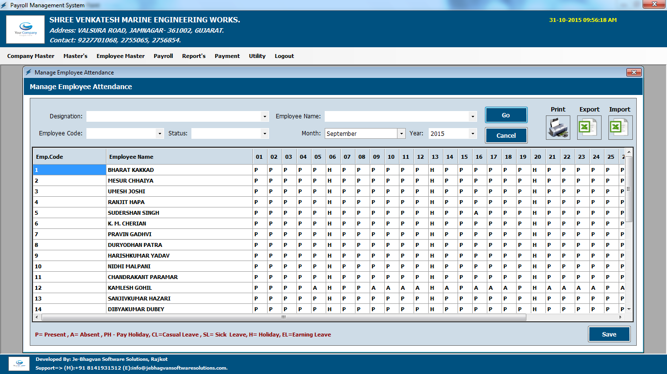

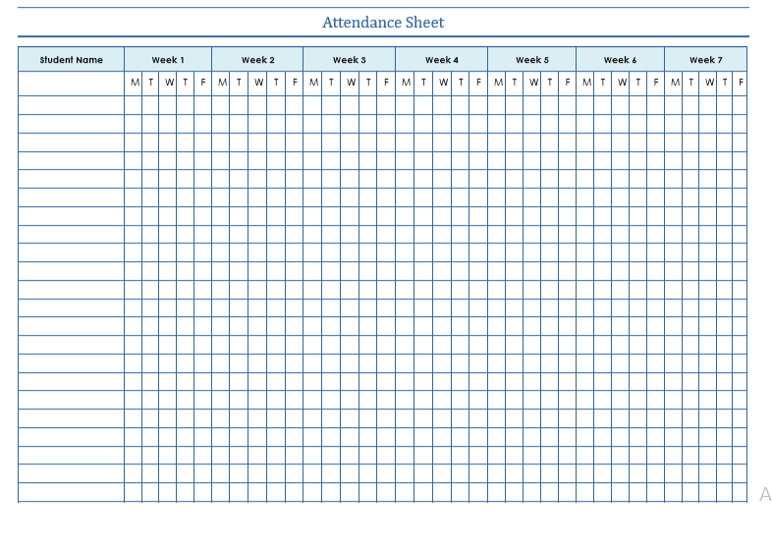

**What is the name of the system?**

**With your lectures hat on,**

Observe what to do in day to day process

Why do you need to complete a role – covid and attendance

Mulit streamed classes

 involve observing what people do as they go about their days in their “natural habitats.” In this sort of interview, the user shows the interviewee how they accomplish certain tasks, essentially immersing the interviewer in their work or home culture. This can help researchers understand the gaps between what people actually do, and what they say they do. It can also shed light on things that users do when they are feeling most comfortable.

**Technique: Qualitative Usability test**

**Method:**

**Justification:**

**Findings:**

**Technique:**

**Method:**

**Justification:**

**Findings:**

# Overall UX requirements for Attendance screen

# The final build will meet the user requirements if the user can do the following (checklist):

# Technology stack will you use for the final build

**Choice:**

**Justification:**

# References

UX booth collaboration (2018, October 17th) *Complete beginners guide to UX research.* UX Booth. <https://www.uxbooth.com/articles/complete-beginners-guide-to-design-research/>